# Germany Air Quality Data Notes

Authors: Monika Roznere and Andy Bean

ToC:

Germany Air Quality Data Notes

Air Quality Historical Data Platform

Berlin: Berliner Luftgütemessnetz

Meteorological Historical Data

## Air Quality Historical Data Platform

<https://aqicn.org/data-platform/register/>

See [folder](https://drive.google.com/drive/u/1/folders/16q97mvezxB5zEgepcV6Q807iTkY53lO2) for example data downloaded from this platform.

Just by typing in Germany:

* Berlin, Germany
* Niederzier, Germany
* Bielefeld Detmolder Straße, Germany
* Datteln-Hagem, Germany
* Münster Weseler Straße, Germany
* Oberhausen Mülheimer Straße, Germany
* Gelsenkirchen Kurt-Schumacher-Straße, Germany
* Duisburg-Bruckhausen, Germany
* Essen-Vogelheim, Germany
* Mannheim Friedrichsring, Germany
* Ulm, Germany
* Neuenburg, Germany
* Mülheim-Styrum, Germany
* Reutlingen Lederstraße-Ost, Germany
* Mannheim-Nord, Germany
* Tübingen Mühlstraße, Germany
* Biberach, Germany
* Kehl, Germany
* Tübingen, Germany
* Reutlingen, Germany
* Stuttgart Am Neckartor, Germany

Note: This data only contains information on the levels of pollutants in a certain area at a certain date. Much of the open air software requires data on the wind direction and wind speed for these days

<https://www.iqair.com/commercial/air-quality-monitors/airvisual-platform/api>

Free version lets you see in real-time only. Proprietary version lets you see 46 hour historical data.

<https://www.epa.gov/outdoor-air-quality-data>

The EPA’s data for US sites (if applicable)

### Berlin Air Quality Monitoring Network

Website: <https://luftdaten.berlin.de/lqi>

Other: <https://www.berlin.de/sen/uvk/umwelt/luft/luftqualitaet/>

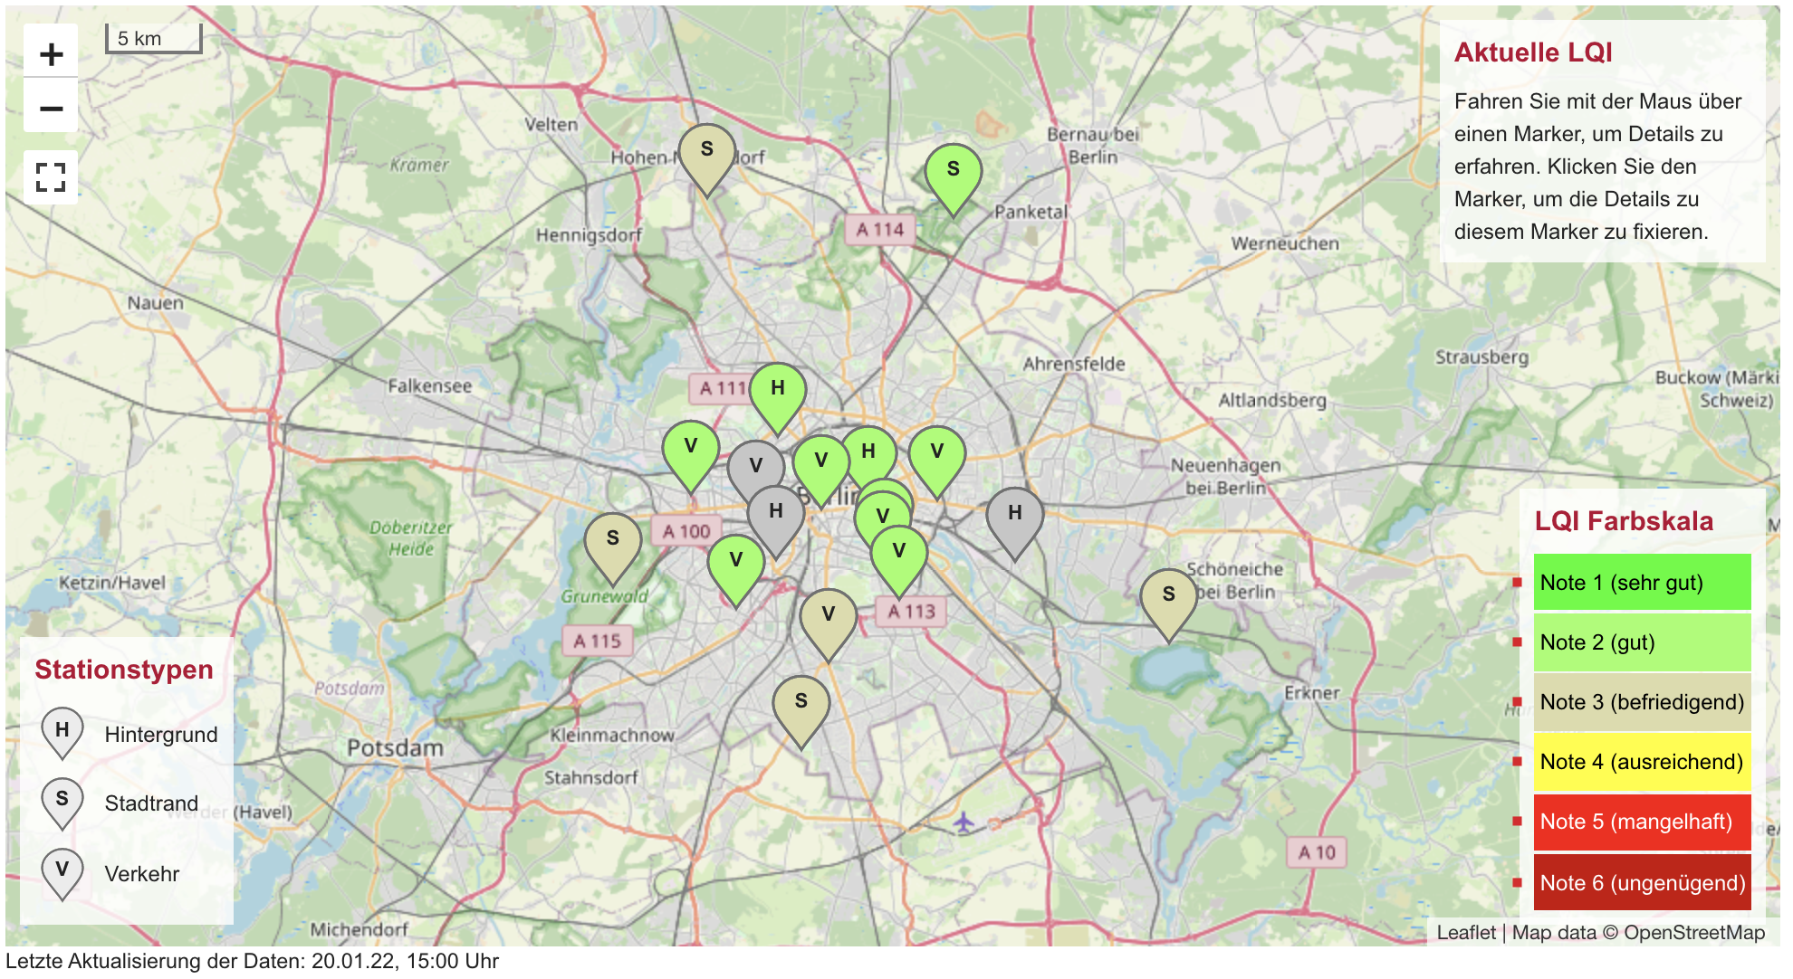

**Notes:**

* Check the table of stations to know what extra parameters are being recorded.

**Station 010 Wedding**

Link: <https://luftdaten.berlin.de/station/mc010?period=24h&timespan=custom&start%5Bdate%5D=19.01.2017&end%5Bdate%5D=18.01.2018>

* Hourly values → max: 1 month visual
* 8-hour values (sliding) → max: 1 month visual
* Daily values → max: 1 month visual
* 24-hour values (sliding) → max: 1 month visual
* Monthly values
* 12-month values (sliding)
* Annual values

Data: <https://drive.google.com/drive/u/1/folders/12IqquWhKrYlqYL1rcOLc75MV0hHN2thj>

Weather data (probably copy/paste and use filtering for further clean up):

<https://www.wunderground.com/history/daily/de/berlin/EDDT/date/2020-1-20>

### 

### 

### Saxony Annual Air Quality

Website: <https://www.luft.sachsen.de/immissionsberichte-14961.html>

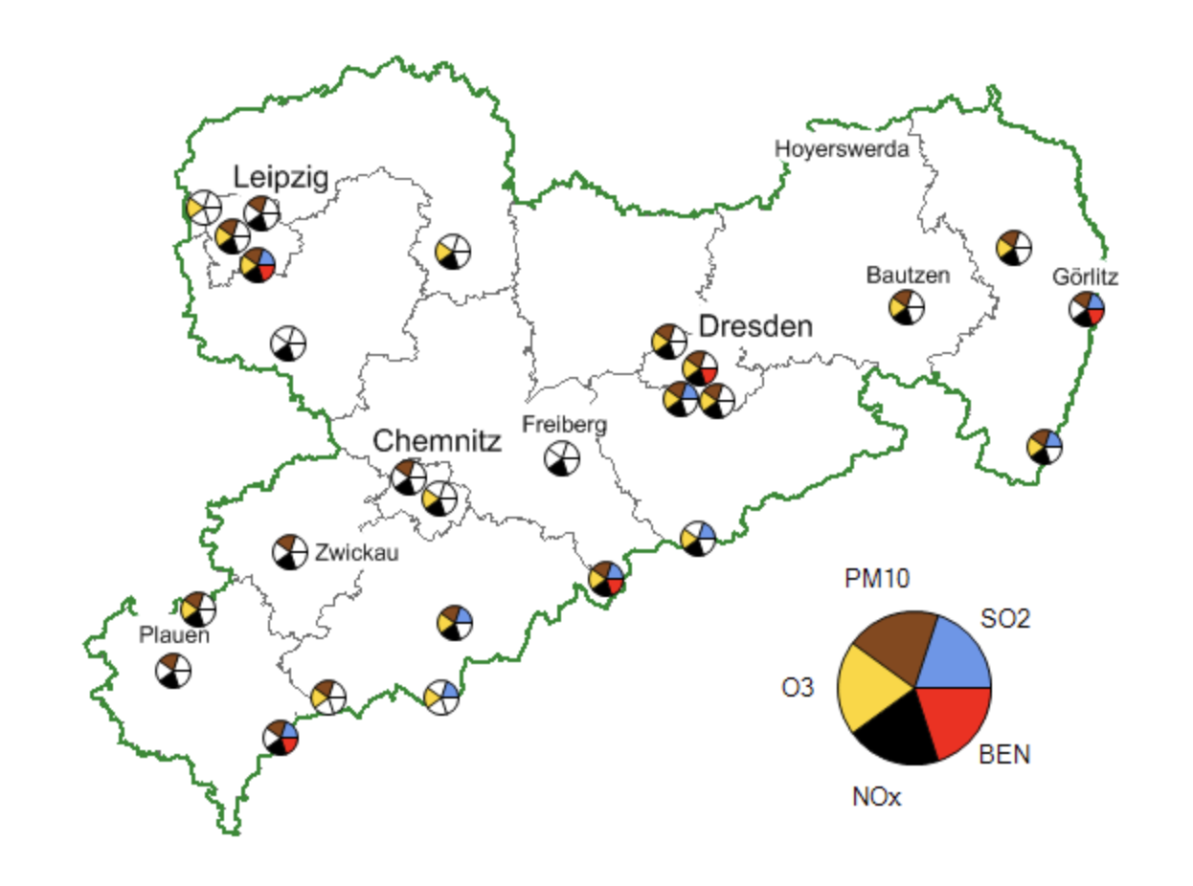

Stations: <https://www.umwelt.sachsen.de/umwelt/infosysteme/luftonline/uebersicht.aspx>

**Notes:**

* Website for retrieving data from a station
  + <https://www.umwelt.sachsen.de/umwelt/infosysteme/luftonline/Recherche.aspx>
* Hourly/daily average → depends on the parameter and station
* Some include wind direction and speed?

### Lower Saxony Air Quality

Website: <https://www.umwelt.niedersachsen.de/startseite/themen/luftqualitat/lufthygienische_uberwachung_niedersachsen/aktuelle_messwerte_messwertarchiv/messwertarchiv/messwertarchiv-9108.html>

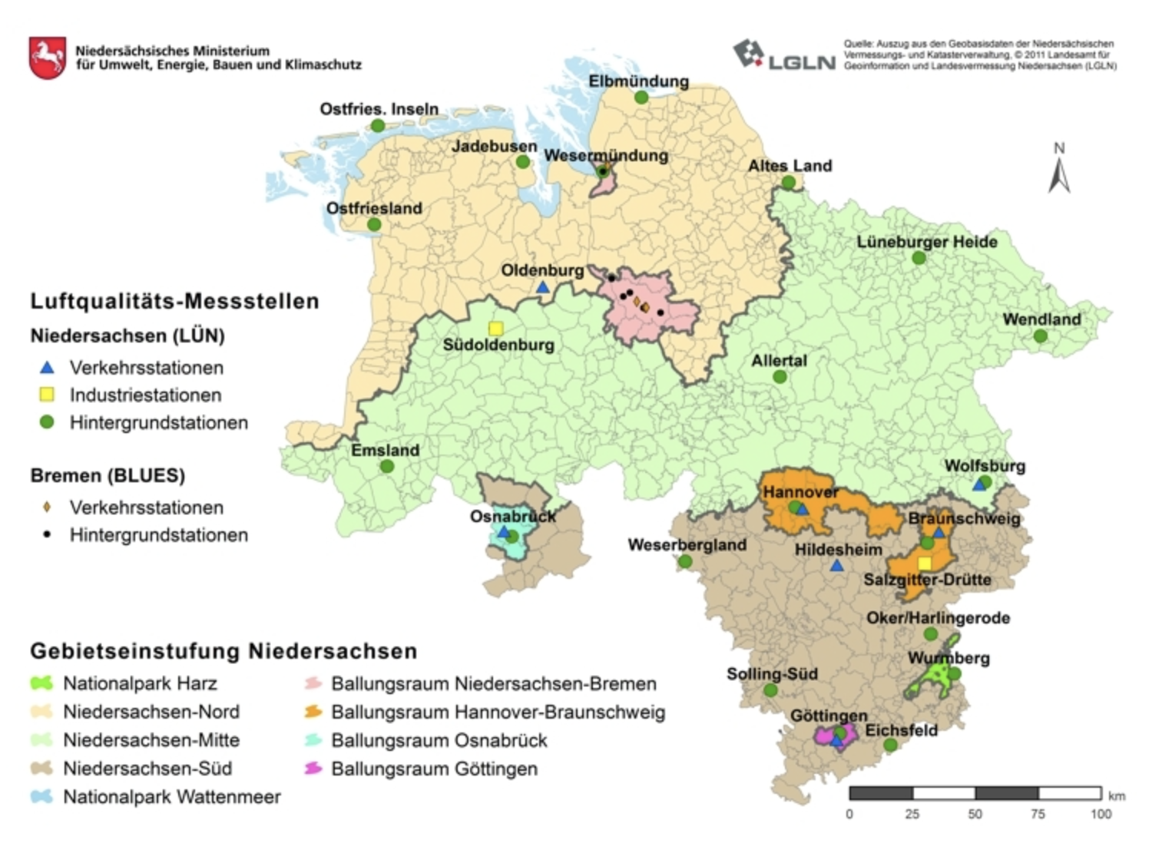

**Notes:**

* 90 day data records
* Lots of parameters, depending on station
* Wind direction and speed included
* Tough to clean but can be done (bad csv format from their website)

### North Rhine-Westphalia Air Quality

Website: <https://www.lanuv.nrw.de/umwelt/luft/immissionen/berichte-und-trends/einzelwerte-kontinuierlicher-messungen>

**Notes:**

* Data there, just need to clean up

### 

### Other Cities: Not Working

Website: <https://www.umweltbundesamt.de/en/data/environmental-indicators?thema%5B%5D=102886>

<https://www.umweltbundesamt.de/en/data/air/air-data>

## Meteorological Historical Data

<https://www.wunderground.com/history/daily/de/d%C3%BCsseldorf/EDDL>

Historical data for different cities in Germany, though needs to be manually uploaded/combined with air quality data.

<https://www.climate.gov/maps-data/dataset/average-wind-speeds-map-viewer>

This site contains US data on wind speeds nationally, but it is in a strange format that can’t be opened immediately. We would have to read directly off the maps produced and input it manually (with the assistance of Matlab, etc. The data is also only a monthly average

* See also direct wind roses for US: <https://www.climate.gov/maps-data/dataset/1961-1990-wind-roses-month-charts>
* See also more historical data in a better format (cardinal direction average and wind speed in mph): <https://www.ncdc.noaa.gov/sites/default/files/attachments/wind1996.pdf>

<https://www.weatherbit.io/>

This looks very comprehensive, and well curated, but it is $180/month to get any historical data we would need (and we would only get 3 years of it).

<https://www.ncei.noaa.gov/access/search/data-search/global-hourly>

This NOAA site contains the Integrated Surface Dataset for the Globe. There are a few locations in Germany

See [folder](https://drive.google.com/drive/folders/19uuYIbkwaRoLoXqE7UPIXTBha7PgsHiE?usp=sharing) for example data

Locations in or near Germany: 